Nmae:Muhammad Arham
Reg#: L1F23BSSE0372
Section : G-1
Docker Setup
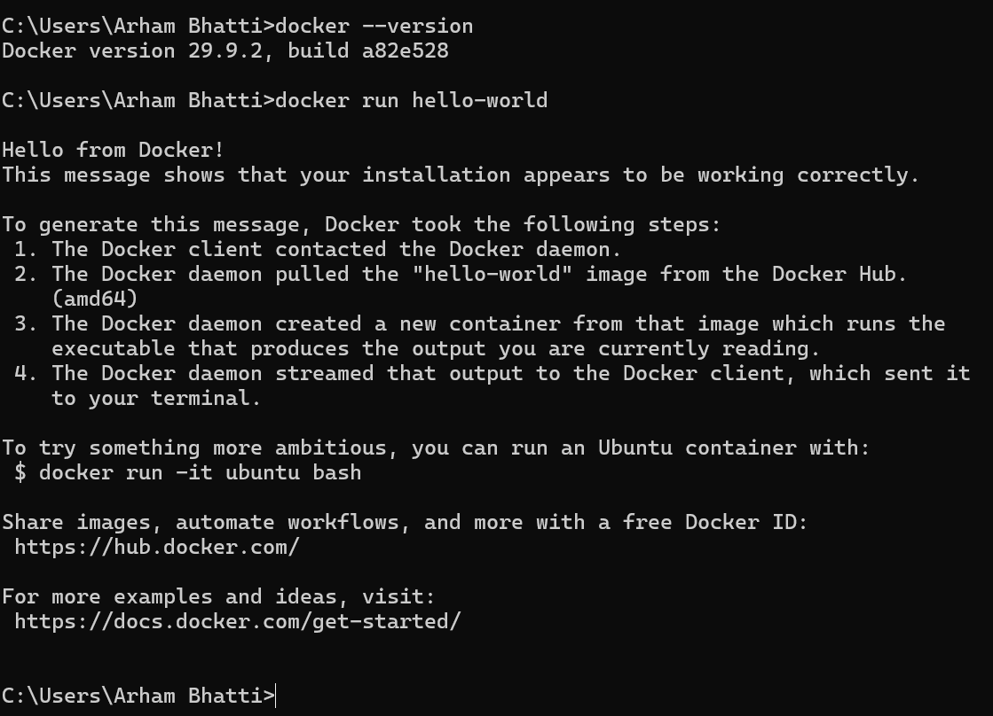

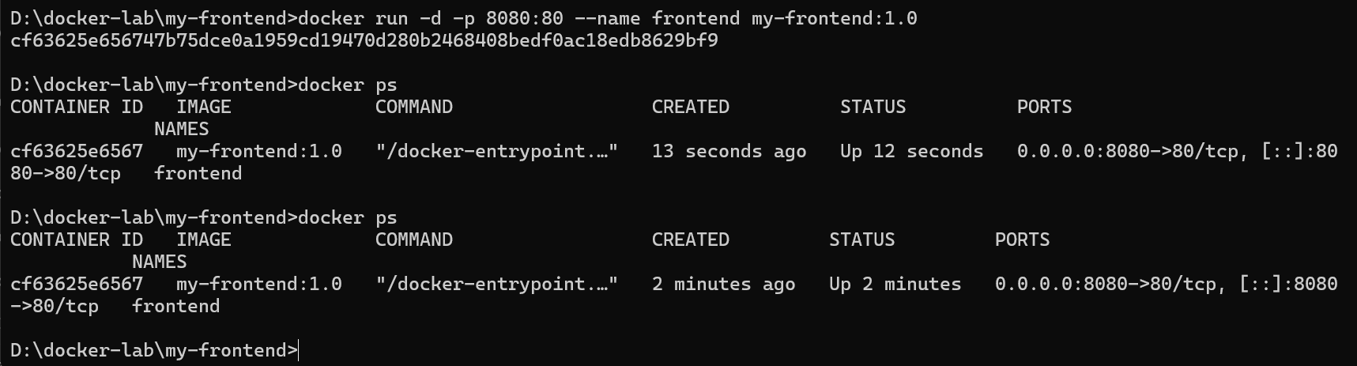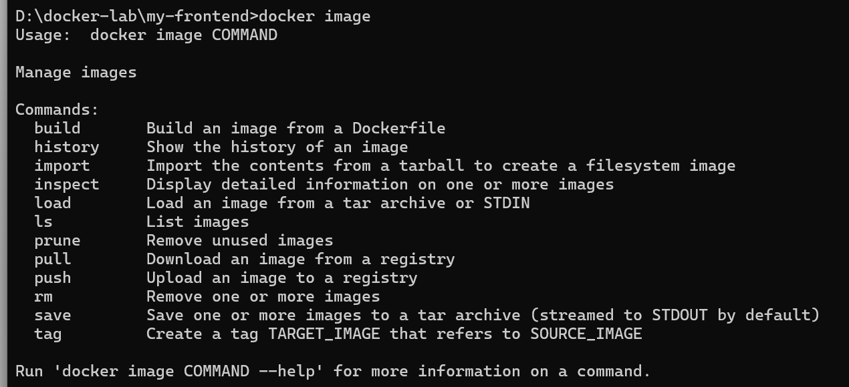

docker logs frontend
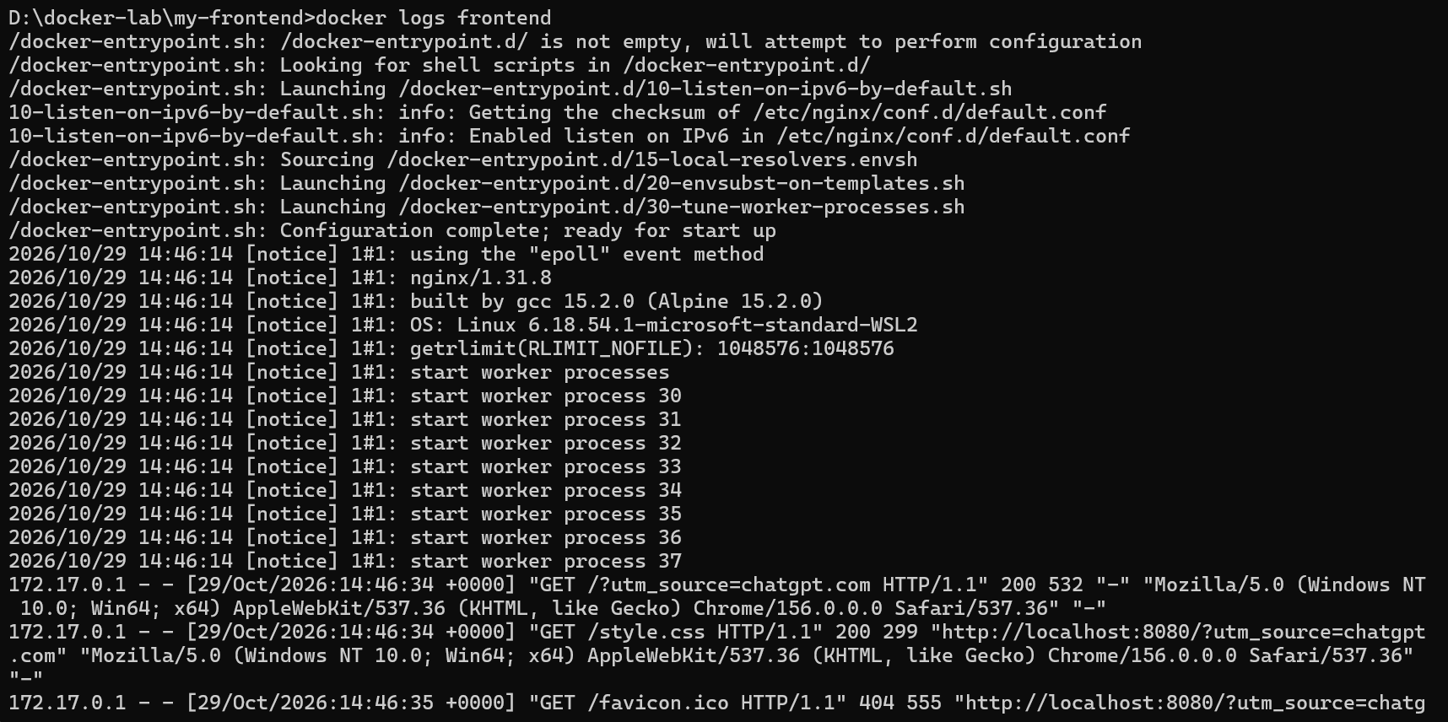
docker exec -it frontend sh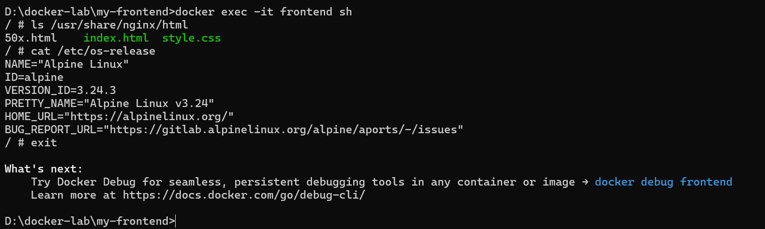
docker ps -a
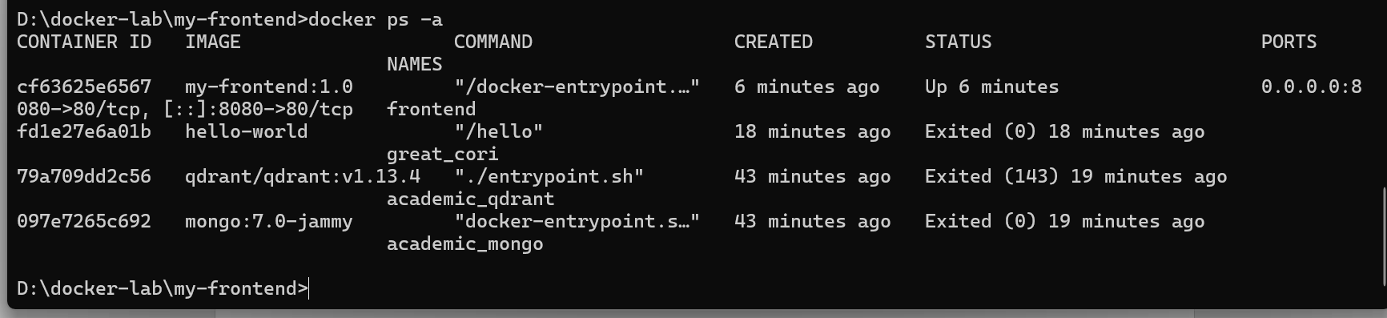
docker start frontend
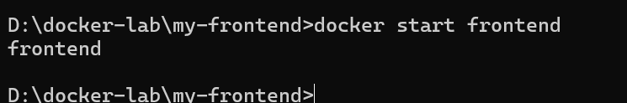

docker restart frontend
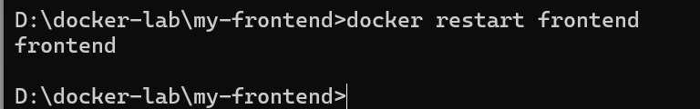
docker exec -it frontend sh
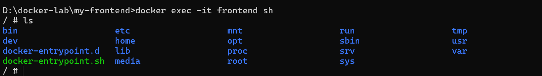docker build -t my-frontend:2.0 .
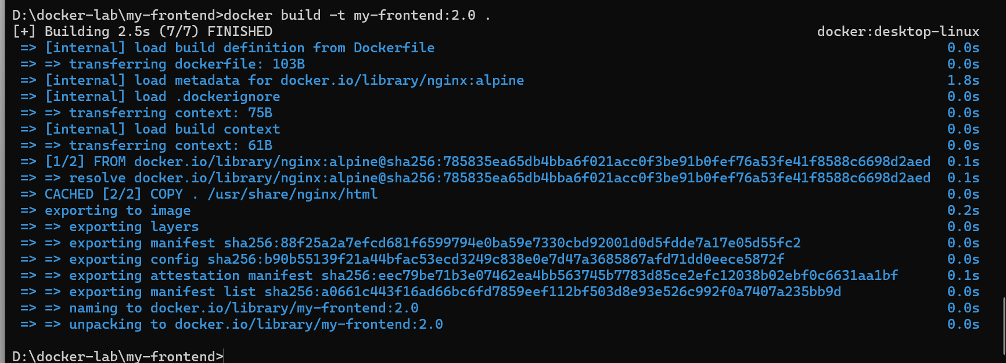
docker rm -f frontend
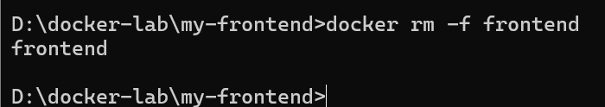
docker run -d -p 8080:80 --name frontend my-frontend:2.0
docker rm -f frontend frontend2 frontend3
docker ps -a
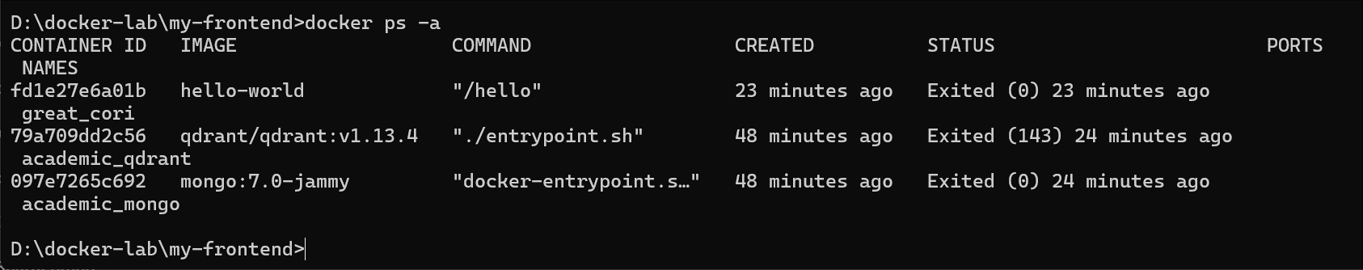
docker images
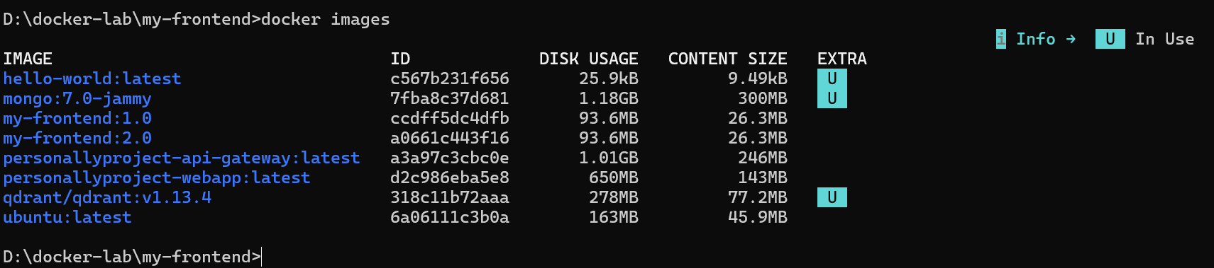
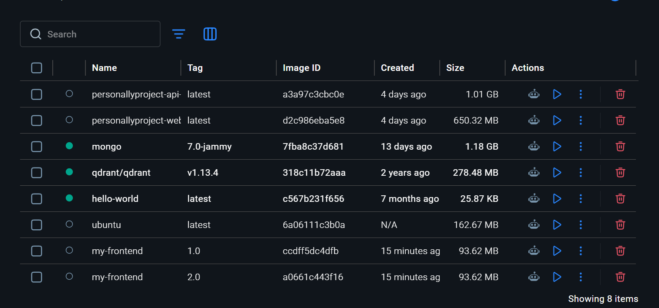
Output


